Chapter 3 - Building a Release Process Workflow

Option 1: Git- based deployments
This is the high-level flow
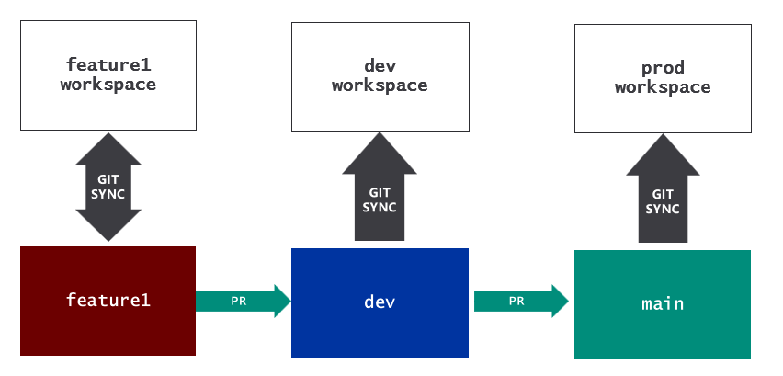

Option 2: Deployment using Fabric deployment pipelines
This is the high-level flow
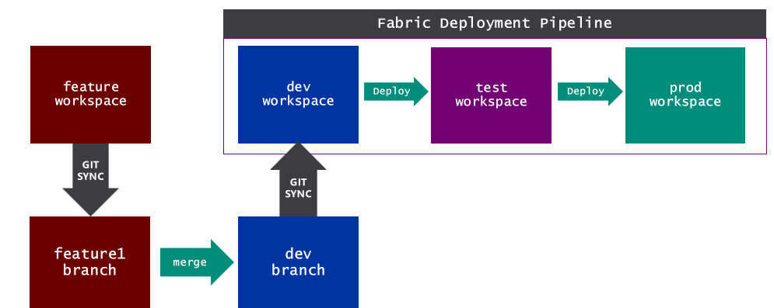

Option 3: Deployment using fabric_cicd
This is the high-level flow

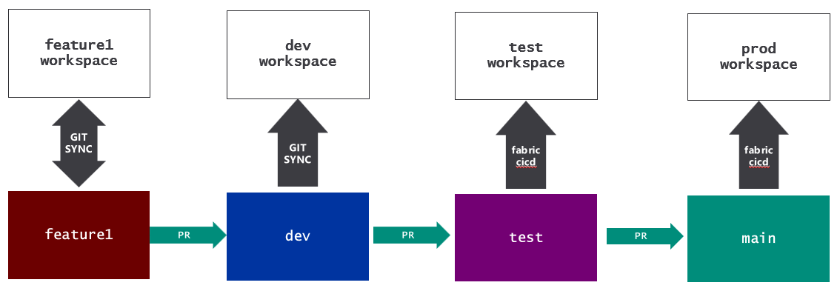

Option 4: Deployment using API-driven workflow
This is the high-level flow

Option 5: Deployment to support multitenancy

Deploy using Import Batch APIs

Multitenant deployment for ISVs

